Typical Dining Etiquette Diagram
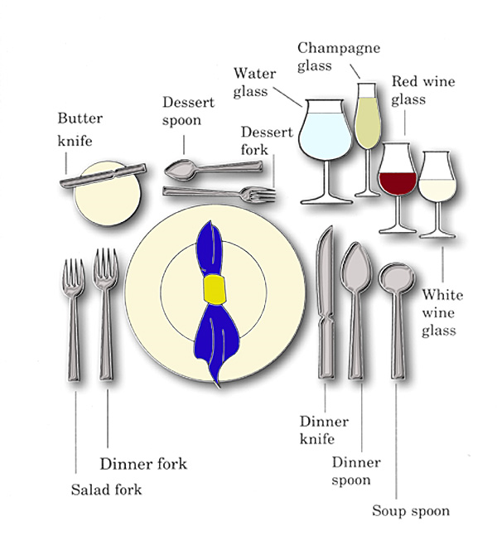

Typical Dining Etiquette Diagram
Typical Dining Etiquette Diagram

Typical Dining Etiquette Diagram

